Dear Parents and Carers,

Welcome to Cayton School and its prospectus. If your child is about to join us for the first time, we welcome you warmly as parents and look forward to a happy and successful association over the coming years. If you already have a child in our school, we are pleased to renew the links between us.
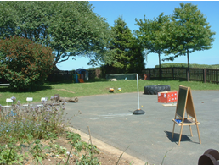
Clearly, as a parent, this is an important time for you. Choosing a school is an important milestone in any family’s history. There will be many fears, thoughts, questions and hopes that you carry at this time.

Why choose Cayton School?
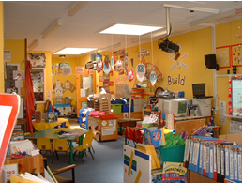
First of all I can assure you that every effort will be made by ALL the staff in school to produce a happy and secure atmosphere in school with mutual respect shown by everyone in our school family. Secondly, we strive to create a learning environment where every child is able to reach their full potential and develop their personalities. We endeavour to achieve the very best for your children in educational, moral, spiritual, social and physical development.

Confidence in a good school comes from knowing and understanding what happens within it. We hope that through school communications, educational and social functions you will soon get to know the members of our school team. This prospectus is designed with you in mind, to answer the questions you may ask.

Finally, may I thank you for taking the time to read this welcome page. Additional information can be found on the school website at www.caytonprimaryschool.co.uk. If you have any further questions, please do not hesitate to contact the school.

Yours sincerely,

Mrs J. Monaghan
Headteacher

School Mission Statement

To deliver the highest educational standards enabling all children and adults to grow, learn and work together in a caring atmosphere where laughter, respect, trust and harmony are highly valued.

Educational Aims

- To help children to develop lively, enquiring and creative minds

- To foster and develop self-confidence and self-esteem

- To help children acquire knowledge, skills and understanding that will enable them to adapt to a rapidly changing world

- To provide a happy, secure, purposeful environment where learning experiences will be both challenging and stimulating

- To develop an inclusive curriculum that will foster relevant thinking, communication and information skills using supportive technologies

- To help children understand and respect religious, spiritual and moral values in a multi-cultural society showing tolerance of other groups, races, ways of life and points of view

- For adults and children to take pride in their immediate environment and to understand and contribute to the care of the community in which they live and work

- To foster friendship & respect regarding all within the school community of equal importance

- To encourage parents and school to work together to educate and care for the whole child

- To build & develop positive attitudes through hard work, commitment and self discipline to maximise achievement

Where is Cayton School?

The school is situated on the outskirts of the seaside resort of Scarborough on the East Coast of Yorkshire. It serves the catchment area of Cayton, Osgodby, Lebberston and Gristhorpe, although children come to us from other areas too.

What facilities are in the building?

Cayton School was opened in 1972 to replace the old building which had served Cayton since 1877. The building has 12 classroom areas, including specialist areas such as an ICT room, an Art Centre and Cookery Suite. There is a large playing field and three tarmac playgrounds, for Early Years Foundation Stage, Key Stage 1 and Key Stage 2.

The hall is used as an assembly hall, dining room, occasional teaching area and gym.

Early Years, Key Stage 1 and Key Stage 2 have their own entrances, cloakrooms and toilet facilities.

The front entrance of the school gives access to the administration area and should be used by all visitors. All external entrances have secure locks, but we do rely on your help to ensure that doors are kept closed. The school perimeter is securely fenced to ensure your children remain safe whilst they are with us.

What happens at lunch time?

The school has its own kitchen which provides hot midday meals each day. Alternatively children may bring a packed lunch to school, or a mixture of the two. Children in the Early Years, Year 1 and Year 2 are entitled to a free school dinner at lunch times.

Is there a school bus?

A public service bus stops just outside of school. Alternatively, children living further afield may be entitled to free transportation to and from school. Please ask at the School Office for further details.

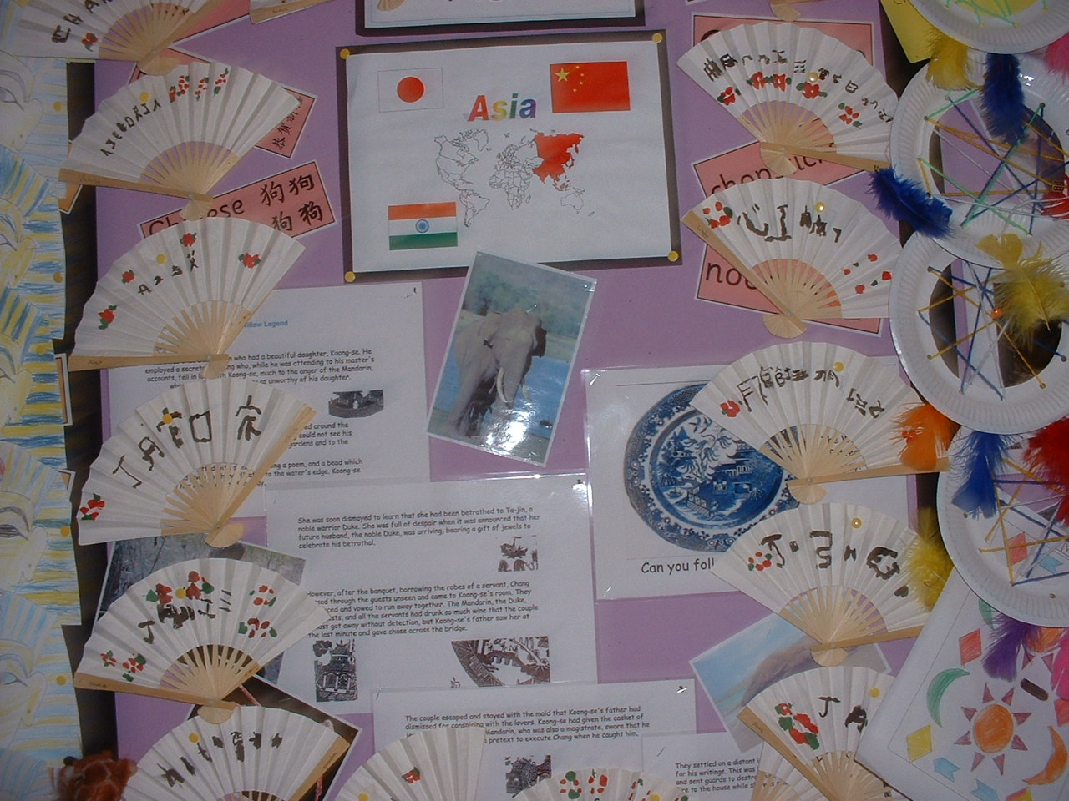

Is there a car park?

Unfortunately we do not have this facility for parents. Parents may park at the start and end of the day in Jubilee Hall car park but spaces are limited. Please do not park on the zig-zag markings or in the school driveway. For your own safety, children and parents should use the pedestrian entrance at all times. The Police and Community Officers carry out regular patrols at the start and end of the school day so please park considerately. The school cannot and does not accept responsibility for any accidents or damage that may occur in relation to car parking outside the school. Please take care!

Does the school offer wrap around care?
The school has a purpose built wrap around care facility on site which is privately run. More information can be found at www.buttercuppreschool.co.uk/outofschool.html

Who is part of the school team?

Our school team is an extensive support network providing the best for the children in our care. It consists of school staff – both teaching and non-teaching; governors; parents; support agencies and the children themselves.

What do the School Governors do?

The school governors are responsible for the school. The day-to-day running of the school is delegated to the Headteacher.

The full Governing Board (GB) of the school meets formally once a term. All parents have the right to read the minutes of GB meetings (apart from those deemed to be confidential) once they have been approved. Formal requests for paper copies can be made to the Chair to Governors via the school.

The GB consists of 12 Governors:

LA Governors (1)
Co-opted Governors (3), currently 2 vacancies
Parent Governors (2)
Staff Governors (4)

The Headteacher is included as a Staff Governor.

Minutes of meetings are taken by the Clerk to Governors. Full details of the Governing Board can be found on the school website.

Useful Addresses:

LOCAL AUTHORITY (LA)

North Yorkshire Council
Children and Young Peoples Service,
County Hall,
Northallerton
North Yorkshire, DL7 8AE

Starting School

Who is entitled to enter the School?

The school welcomes all children and there is an equal right for all children to have access to the school and the provisions made therein.

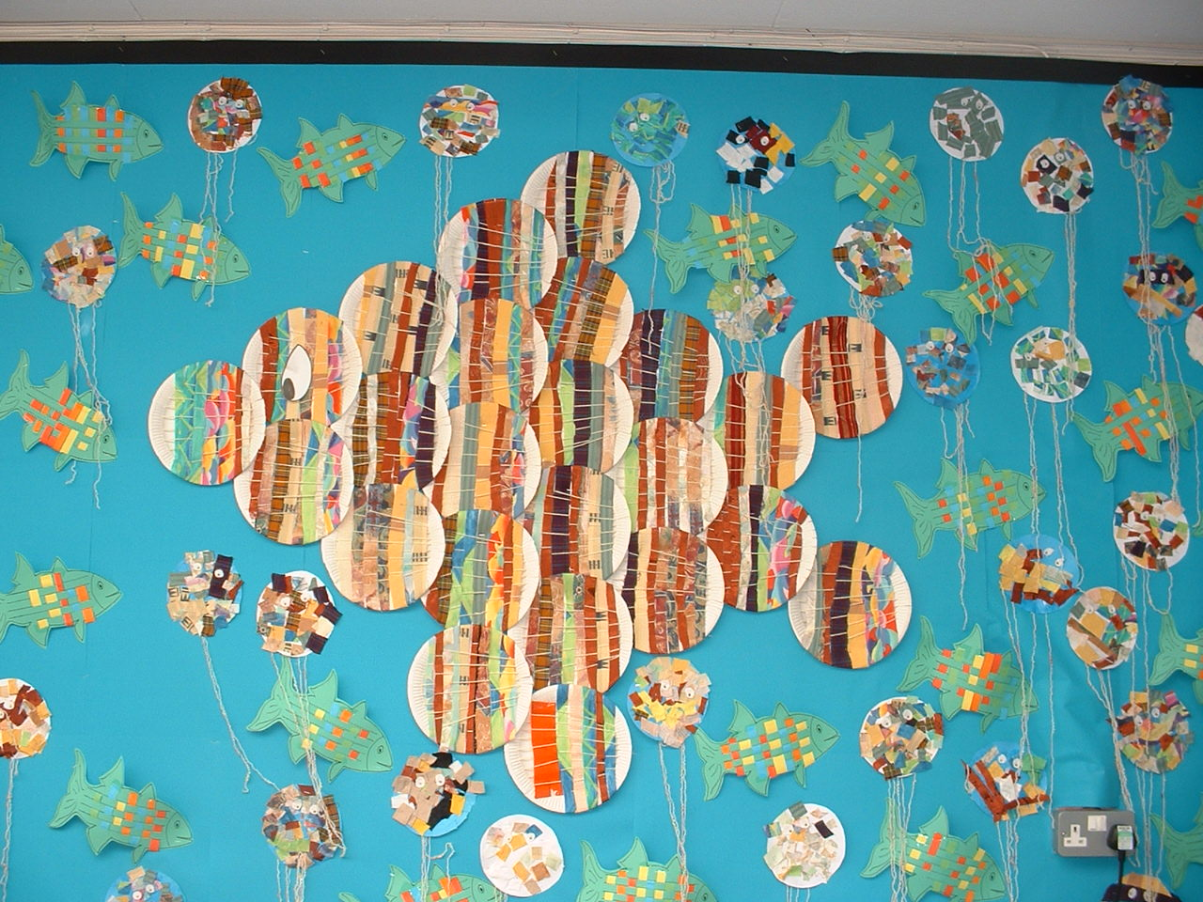
What are the admission arrangements for the School?

When allocating places to attend School, the LA uses various criteria, including Special Educational Need. Places are given to applicants who reside in the school’s catchment area. Thereafter, consideration will be given to those children who live outside the catchment area. Further information can be found on North Yorkshire Council website, in the section education and learning/school admissions.

How do I apply?

Please contact the school for initial registration. You must apply for a place to the LA by completing the on-line application at www.northyorks.gov.uk. (a link exists on our school website).

What are my options?

If your application is successful, you will be informed in writing by the Local Authority and have a short space of time in which to confirm the offer.

If your application is unsuccessful, there is an appeals procedure. Please contact the Local Authority for details.

When can my child start School?

Children are able to start school in the September following their 4th birthday.

Will I get an introduction to School?

Our new starter meeting will take place in June, with the class teachers and headteacher. You will be given a pack of information for you and your child. In July, you and your child will be invited to a personal ‘Meet and Greet’ session to support their transition to school life. In the 1st week of September your child will start school, the exact date will depend upon their date of birth.

What if my child joins the School during a School year?

We welcome children at any time in the school year. If you are considering joining us, please ring and make an appointment to look around.

School Times and Organisation

How are the classes organised?

Currently the school is organised into 7 classes with 1 class per age group. Whenever possible, children of the same year group are placed in the same class, but because of the variation in numbers in every school year, this may not always be possible.

How is the School day organised?

School commences 08.50
Morning break Variable times from class to class
Lunch – EYFS children 11:50 - 13:00
Lunch – Y1 to Y6 children 12:00 - 13.00
School finishes 15.20

Teaching Staff are on duty from 8.40 AM. If your child arrives before this we cannot guarantee that there will be staff to supervise them. Staff are available at the end of the day, should you need to speak with them.

What are the School rules?

These are few and are in place for the safety and welfare of all the children in our school community. We believe in firm but fair discipline, with an emphasis on self-discipline. Our approach is based on praise, recognition, rewards and sanctions. Cayton Awards are given for making positive contributions. We expect your child to consider others. If your child does not behave in an acceptable manner, we will share our concerns with you, so that we can work together to modify behaviour. The behaviour of a child is a joint responsibility between the child, yourselves and the school.
SCHOOL RULES
- THINK carefully about what you say to and about others
- Keep school a SAFE place to be
- LISTEN carefully to good advice
- Be KIND - don't hurt or upset people

How do the children help to run the School?

There is a ‘School Council’ enabling children to join in the decision-making process of the school. Children also have responsibilities at lunchtimes and break times such as, being playground buddies and helping run the school library.

What are the lunchtime arrangements?

Meals are cooked on the premises daily and we operate a canteen style lunch. We would encourage you to let your child have a healthy cooked lunch where possible. Children in EYFS, Year 1 and Year 2 are entitled to a free school meal at lunchtime. For all other year groups, it would help the School Office if meals could be paid for in advance via ParentPay. Children are supervised by Midday Supervisors (MSA’s) at lunchtime. If your child is not staying for a school dinner, we would encourage you to provide a balanced, healthy packed lunch.

Are snacks allowed at break time?

Fruit may be sent in from home for morning break time. Children in EYFS, Year 1 and Year 2 have access to daily free fruit from the Governments ‘free fruit’ scheme.

Early Years Curriculum and National Curriculum

What is the Early Years Curriculum (EYFS) and the National Curriculum (NC)?

These consist of areas of development in the Foundation Stage (EYFS) and subjects which all children must study at school when in Year 1 to Year 6 (NC).

What are Key Stages?

The Early Years and National Curriculum organises children into Key Stages (KS).

Foundation Stage (EYFS) 3-5 years
Key Stage 1 (KS1) 5-7 years
Key Stage 2 (KS2) 7-11 years

What about testing?

All children have to be assessed to monitor their progress during their time at school

Foundation Stage - ongoing as part of the children’s day to day work including a baseline assessment during the first couple of weeks at school
Year 1 - phonics screening towards the end of the Summer term
Year 4 - Multiplication check
End of KS2 - tests + teacher assessment for writing, reading, grammar, spelling, punctuation and mathematics

The dates of these tests are well publicised and we would encourage parents not to request leave of absence during these times.

What is the School Curriculum?

The school curriculum contains the following elements:

- Early Years Foundation Stage (Statutory Framework for EYFS)
  - PRIME AREAS
  - Communication and Language
  - Physical Development
  - Personal, Social and Emotional Development
  - SPECIFIC AREAS
  - Literacy
  - Mathematics
  - Understanding the World
  - Expressive Arts and Design

                - National Curriculum (Years 1 – 6)

  - English
  - Mathematics
  - Science
  - Computing
  - Design Technology
  - History
  - Geography
  - Art & Design
  - Music
  - Physical Education (PE)
  - Religious Education (RE)
  - Personal, Social Health, Citizenship Education (PSHCE)
  - Modern Foreign Language (KS2)
  - Sex and Relationships Education
  - Other Areas

Wherever possible the school actively encourages visitors into school and visits outside of school to supplement the school curriculum.

What will my child learn at Cayton School?

“Teachers make sure that they plan tasks and learning opportunities that
take account of pupils’ interests and use stimulating resources to excite
interest and develop a life-long love of learning.”
OfSTED

Details of the curriculum can be found on the school website - www.caytonprimaryschool.co.uk or by speaking with your child’s teacher who will be able to provide you with additional information.

Are there extra-curricular activities?

These change termly and details will be communicated to you.

Other Aspects of the Curriculum

Do I have to pay for any educational visits?

Under the 1988 Education Act, where cost is involved, we ask parents to make a voluntary contribution towards the cost of the proposed visit. Without these voluntary contributions it can be very difficult for visits to go ahead. We believe that they enrich the curriculum and make it come to life. There is no obligation to pay. If, however, an activity cannot be funded from parental contributions then, unfortunately, a visit may have to be cancelled.

What about Sex and Relationships Education?

Sex and Relationships Education is statutory from September 2020 and is part of the National Curriculum. Content is appropriate to the age and the maturity of individual pupils.

Our Sex and Relationships Education Policy (SRE) is approved by Governors. Where children ask questions, answers will promote moral values and the value of family life.

What about Religious Education (RE)?

The school is not connected specifically to any church and provides non-denominational religious education for all children. Reference is made to the LA agreed syllabus for RE.

Parents have the right to withdraw their child from RE or worship and, where this is requested, suitable arrangements will be made.

Assembly themes reflect stories and drama relating to school work. Good Work assemblies are held on a regular basis and the school welcomes carefully vetted visiting speakers.

How will I find out about my child’s achievements?

All parents are invited by letter to ‘open evenings’ in the Autumn and Spring Terms to discuss with the class teachers progress being made by their children. There is also a full written report sent home and an open afternoon, both at the end of the Summer Term.

How will my child be supported if there are special learning needs?

If a difficulty does arise at home, however small, which may affect the routine of your child. We do encourage all parents to discuss the matter confidentially with the class teacher. Teachers are often available before and after school. If however, it is a matter that might take time to discuss, it would be helpful if you could make an appointment to see your child’s teacher.

Where extra help is required there is a designated member of staff (SENDCo) who organises extra provision.

The aims of SEN provision are to:
- Identify and assess children with special needs
- Include SEN children alongside their peers where possible
- Meet the individual needs of children through an inclusive curriculum
- Form and maintain links with parents and outside agencies
- Tackle child protection issues

How does School communicate with me?

Parents of children in EYFS have access to Tapestry and school uses Class Dojo to communicate with children and parents at home – this is the main form of communication between parents and class teachers.
We are also part of ParentPay, a cashless payment system and the way information will be communicated to you from the school office. Please sign up to ParentPay as soon as you can once your child has started school with us

Is there a PTA?

Every parent is welcome to join the ‘Friends of Cayton School’ (FCS), which is run by a small but active committee.

FCS hold a variety of events throughout the school year to raise money in order to support the work of the school.

What if my child becomes ill during the school day?

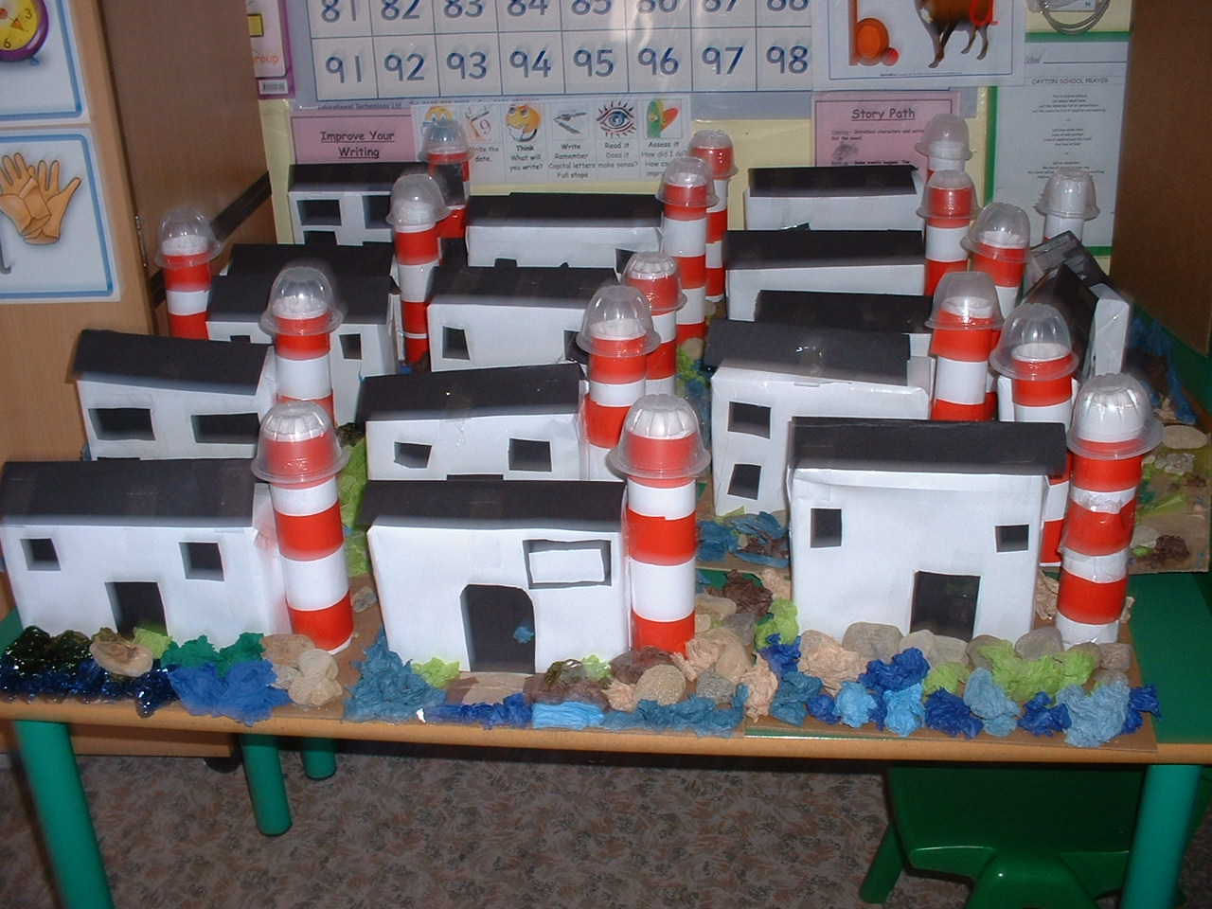
There will be times when we need to make a phone call to you so that you can take your child home. It is essential that we have emergency contact details. Please inform us of any changes to these.

What if my child needs medicine during the school day?

If your child needs to take any medication you need to speak to the office staff and complete the relevant forms including dosage and time.
Any prescribed medication must be brought to school in its original container and held by the office, not by the child.

What if my child needs to be absent from School?

Please let us know as soon as possible on the first day of absence. Following our first day absence policy, if we have not been able to make contact with yourselves when your child is absent, members of the senior leadership team will follow up with a home visit. You are asked to refrain from taking holidays during school time (leave of absence). Parents do not have an automatic right to take their children out of school for the purpose of a family holiday. Taking children out of school without prior approval, may result in a fixed penalty fine being issued by North Yorkshire County Council.

Can my child leave school during the School day?

Where a child has to attend a visit to a dentist, optician or hospital please let us know by letter/dojo / telephone call in advance. Children should be collected from the office area.

Is my child allowed to wear jewellery in School?

For the purposes of safety of the children, no jewellery should be worn by them in school time. Where a child already has pierced ears, then only one pair of small studs are acceptable but not encouraged. The school cannot be held responsible for any injury or loss caused as a result of wearing jewellery. All piercings must be removed or covered during PE for the safety of everyone.

What other safety issues do I need to be aware of?

- Dogs (unless registered guide / hearing dogs) are not permitted into school at any time.
- The school field or grounds should not be used out of school hours, except by prior arrangement with the Governors.
- It is up to parents to arrange any other personal accident insurance. School has undertaken limited personal accident insurance for children taking part in school activities.
- No responsibility can be accepted for monies or valuables in school.
- The school building and school grounds are strictly no smoking areas.

Where do children transfer to Secondary School from Cayton?

Most of our children move on to George Pindar School (GPS) at the age of 11 years. Secondary school staff visit Cayton to see the children. There is also an opportunity for the children and parents to spend time at GPS. School also has links with other secondary schools in the area and similar arrangements are in place.

What documents can I see relating to the School?

Under LA regulations, parents can have access to all LA documents relating to the curriculum. If you wish to see any, please make a request at the Office.

All DfE documents are available on their website www.dfe.gov.uk

How do I make a complaint?

In the event of a complaint arising about the school, the complainant should, first of all, approach the Headteacher. If the Headteacher is unable to resolve the matter satisfactorily, it should be referred to the Governing Board and/or the LA. A copy of the Complaints Procedure is kept in school for parents to see.

How can I arrange a visit to School?

Parents are invited to contact the school at any time. A member of staff will arrange a mutually convenient time for you to visit the school with your child. Full information about joining the school will be provided.

What arrangements are made prior to my child starting School?

A simple admission form can be completed by parents.
Depending on when your child joins us there may be introductory sessions available to you.
Children to be admitted to the EYFS class will be able to spend some time in that class at a ‘stay and play’ before they start their education.
Older children who have already been to school elsewhere will be shown the school with their parents and will meet with individual teachers.

What forms will I have to complete?

Forms to complete will include the following:

- LA admissions (this is done online at www.northyorks.gov.uk)
- Personal details form
- Home / school agreement
- Local visits and photograph permission form
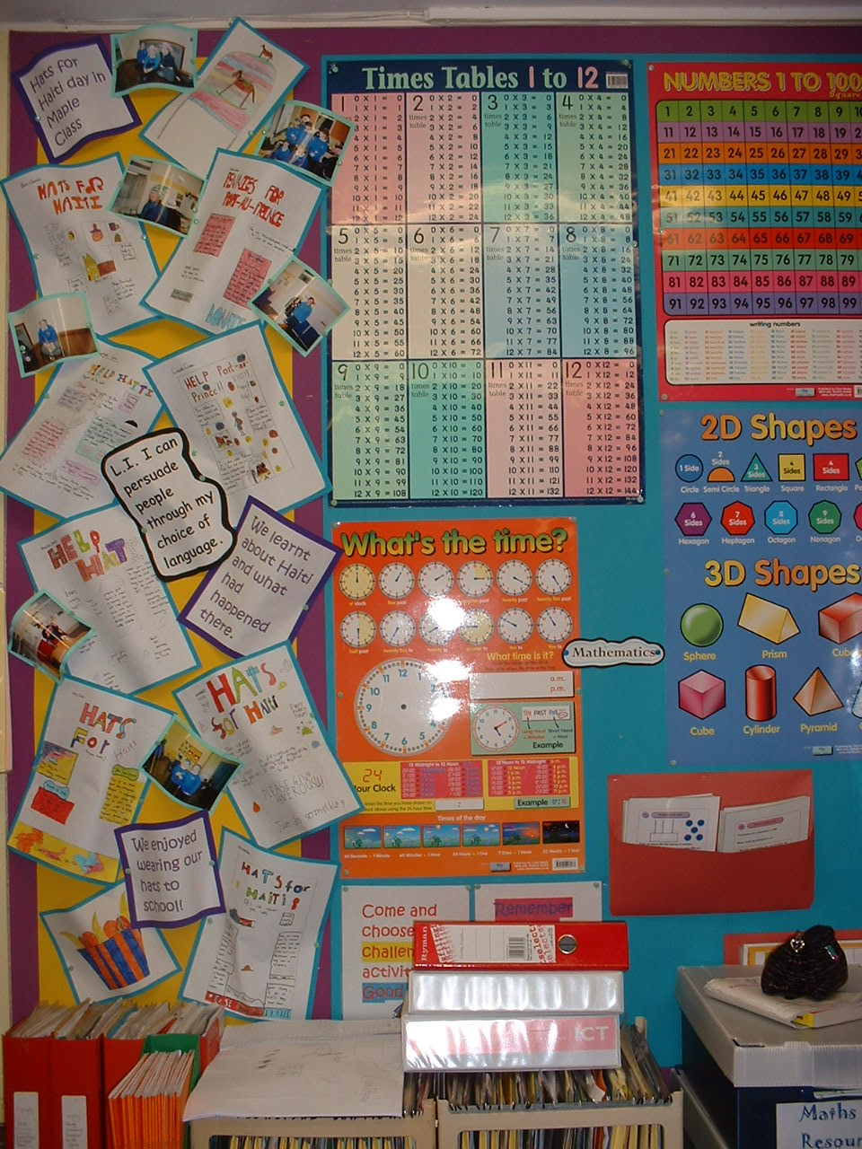
What is the School uniform?

We ask that children should come to school dressed in school uniform. Children are not permitted to have extreme hair colours during term time (natural coloured dyed hair only).

- Grey trousers (short or long)
- Grey pinafore dress or skirt
- Blue and white gingham dress (summer time)
- White shirt / polo shirt / blouse
- Royal blue jumper / cardigan
- Grey, black or white socks / tights
- Black or brown shoes

Sweatshirts, cardigans and polo shirts are available from the www.identity.co.uk
Our up-to-date uniform policy is available on our school website.

What about PE?

Children will require plimsolls, tee shirt (plain white or with school crest available from the Office) and royal blue or black shorts.

Children may take part in outside PE and Games during all seasons and therefore trainers and suitable warm outdoor PE wear should also be available.

Please ensure that your child’s clothing is clearly named.

May we thank you for taking the time to read this prospectus.

We hope that it has given an insight to life within Cayton School.

Naturally any prospectus can only answer some of the questions that parents may wish answering. If there are any other questions that you have, please do not hesitate to contact us and/or arrange a visit to the school.

You and your child will be given a warm welcome.

Mrs. J. Monaghan
Headteacher

School reserves the right to change or amend the arrangements in this prospectus should circumstances make it necessary. Parents will, of course, be informed of any such changes before they occur.
Updated June 2024

