My new school

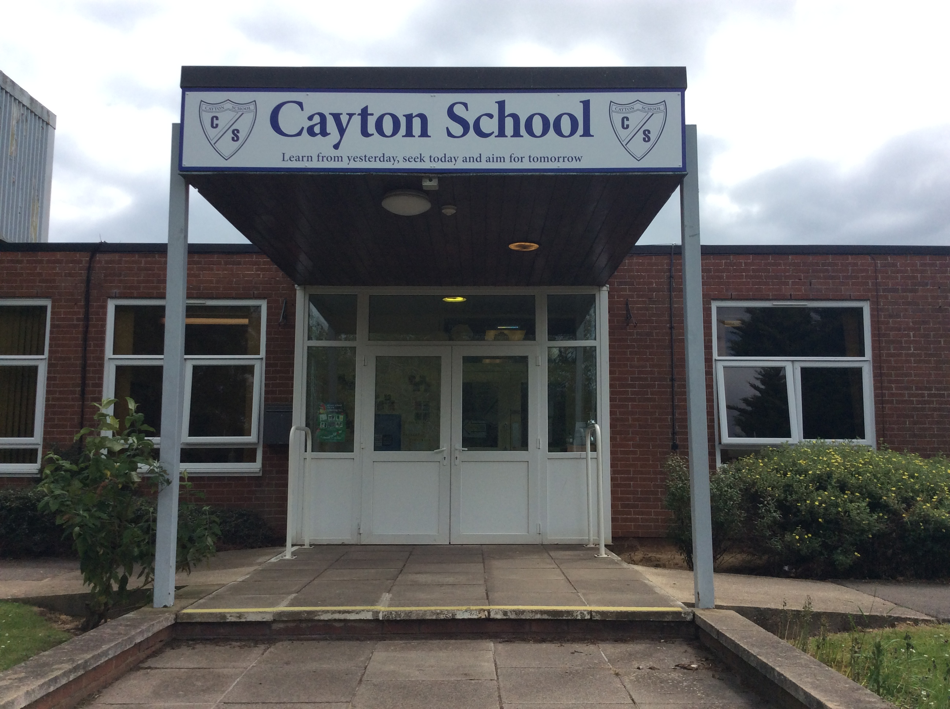

This is my new school. It is called Cayton School.

This is my classroom; it is called Ladybird Class.
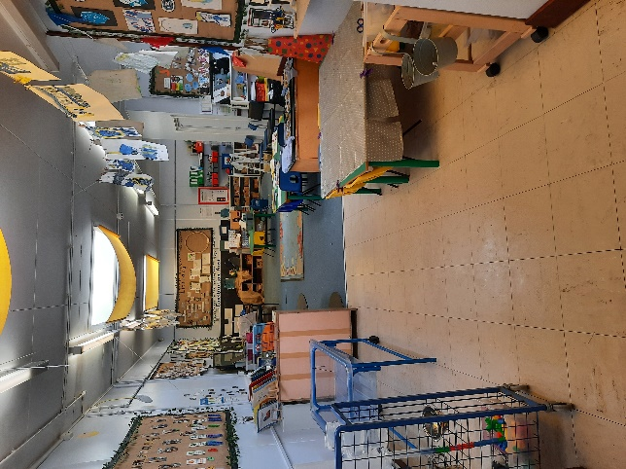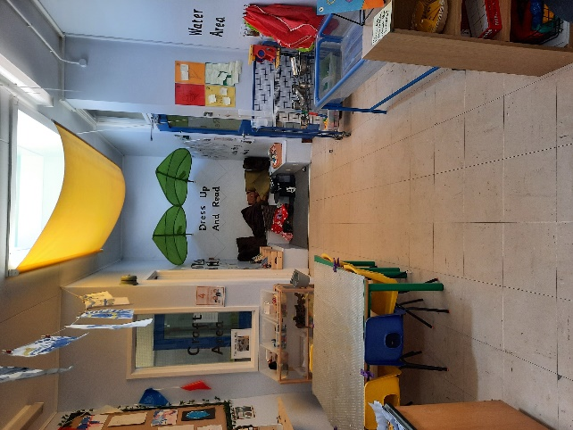

These are my teachers,
Mrs. Oliver and Miss. Forrest.
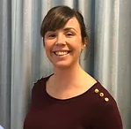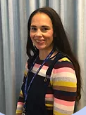

These are the Teaching Assistants who will work in my class and help me with my jobs.
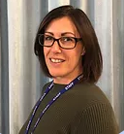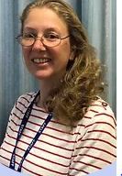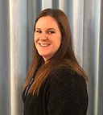
Miss. Stacey, Mrs. Brannan & Miss. Bulman

This is the cloakroom, this is where you will leave your coat and bag. They will be safe here.
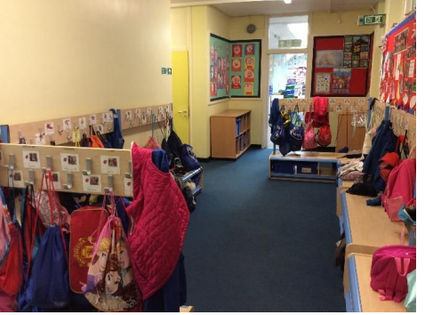

These are the drawers where you will put your book bag. The drawer will have your name on.
It will be safe here.
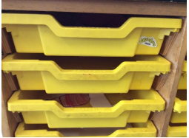

This is the outdoor area, this is part of Ladybird Classroom. You can play and learn in this area too. 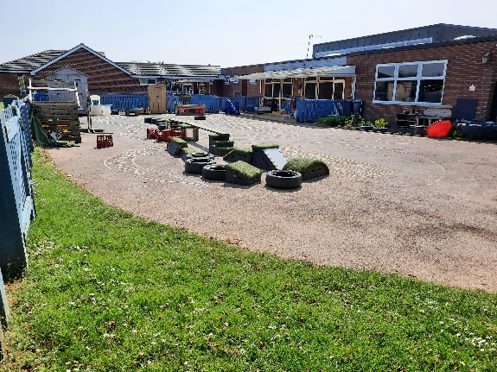
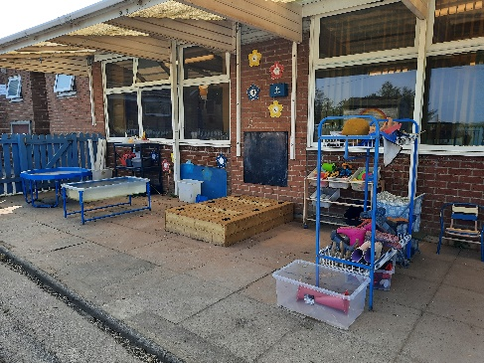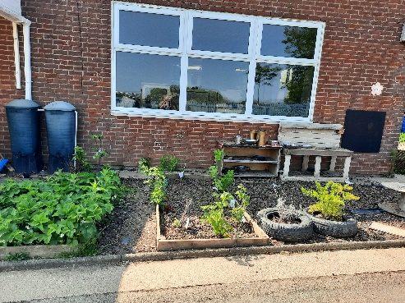
At lunch time, you will eat in the hall. You will line up with your class and the mid-day supervisors will look after you.
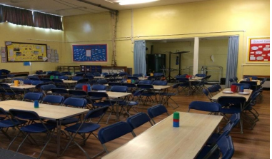

These are the toilets that are in Ladybird Class.
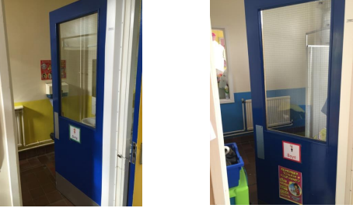

At home time you will be collected by your grown up. They will pick you up from here.

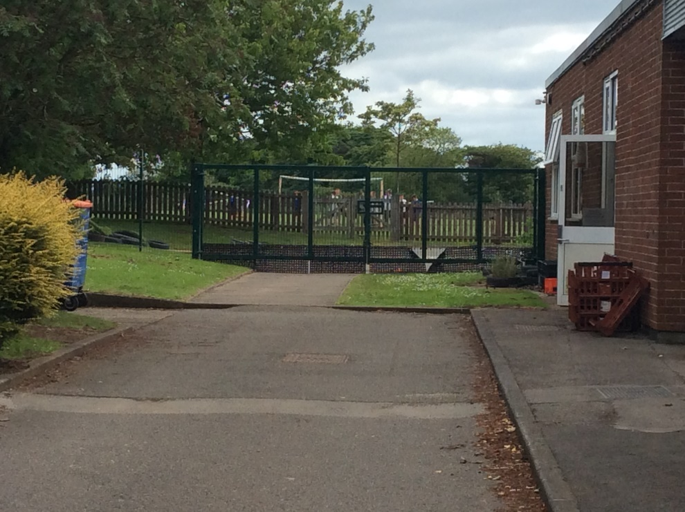

We are looking forward to meeting you in September.
Have a lovely Summer.

