**03 and 4.12.24 Celebrating Differences 2 sessions**

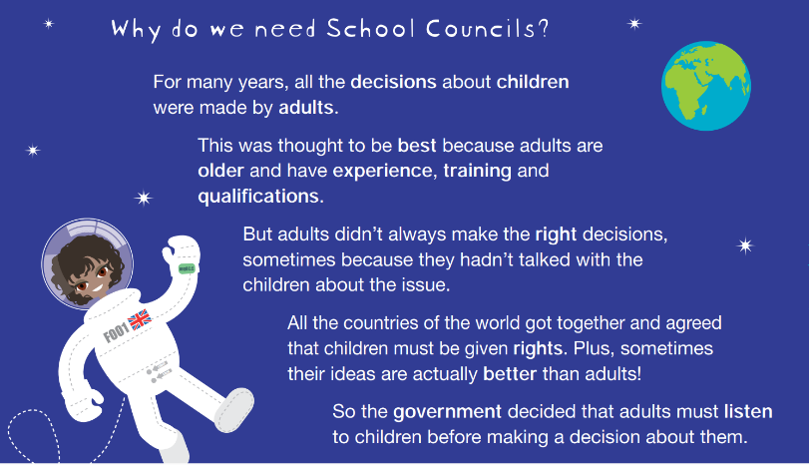

**This week we discussed our role as school council members and tolerance, respect and British Values linking to celebrating differences.**

**We also looked at the school council handbook and spoke out loud to our classes (assisted by the chair and vice chair of school council who are year 6 pupils). We asked our classes for school improvements/ideas. Here are some from one of our year 5 members:**

* **Fundraising for new playground equipment e.g. obstacle course**
* **More football goals**
* **Tidier cloakroom and toilet area in Year 5 and 6**
* **More posters and books to support the eco team**