**20.11.24** 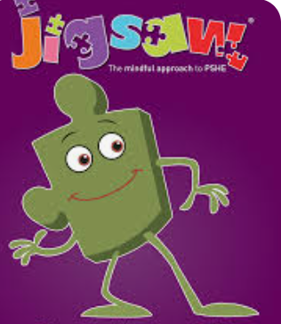We discussed in School Council ‘Celebrating Differences’ and all of the clubs and unique hobbies we have – from judo to ballet. We said that we now have musical theatre club and many other new clubs in school and discussed the possibility of more.

**We then researched books on the environment and space (as per request from the eco team and Mrs Wood)**

**Here are some of the books that we ordered…**

