**School Council- Being in My World**

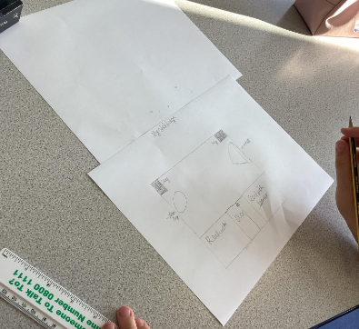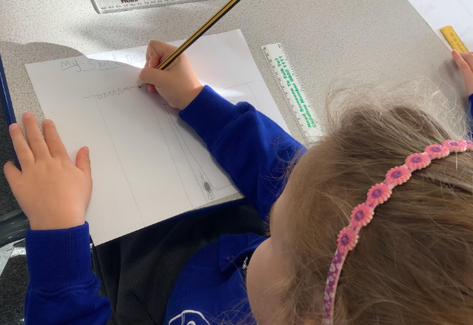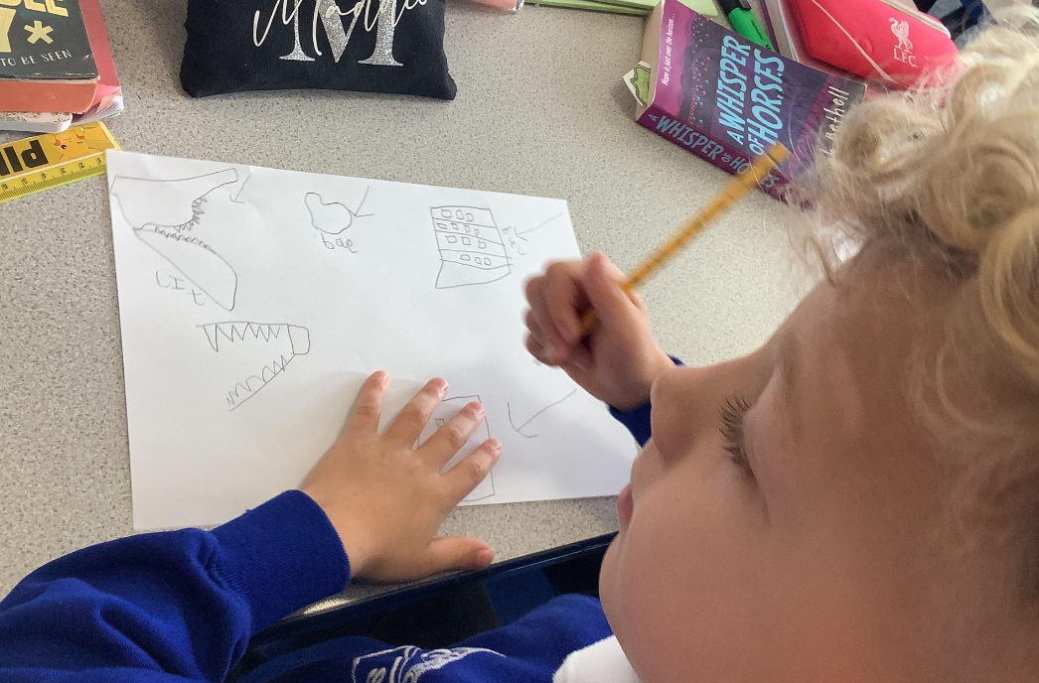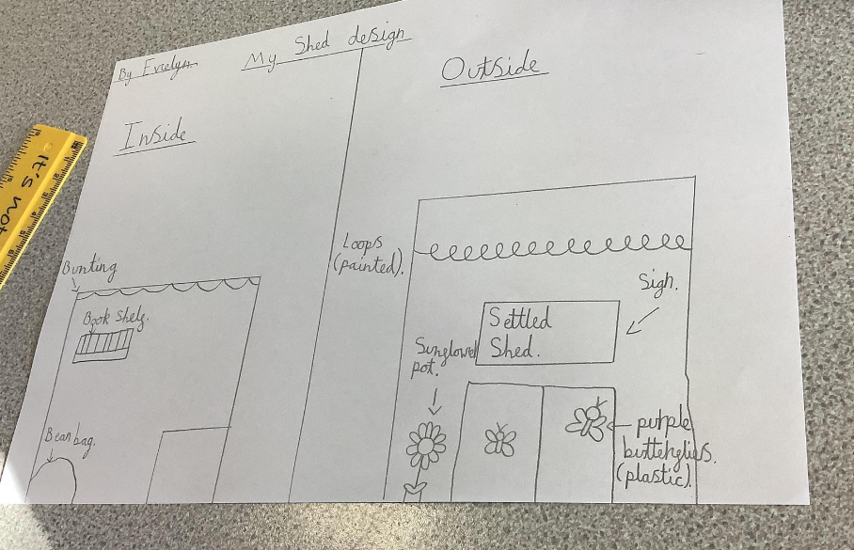This week we came up with some amazing designs for the inside and outside of our new reading shed. Mrs Monaghan (our headteacher) was very excited to hear this! Mrs Draper (me) told school council members that bookcases could be made out of wood or bought as well as beanbags- then they came up with other brilliant things…

