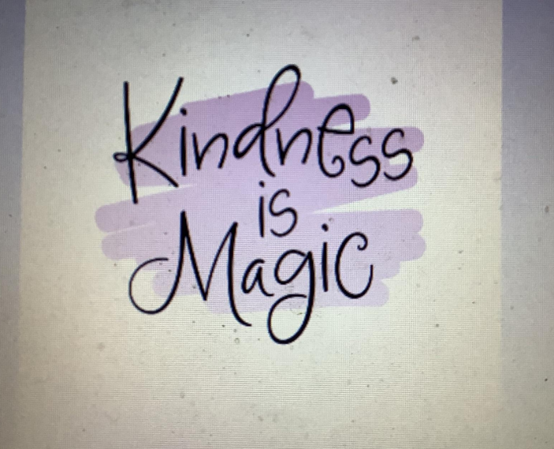
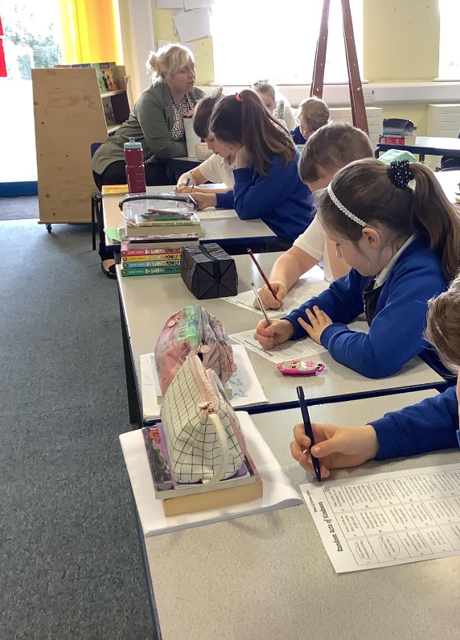
Healthy Me- Minutes 26.4.24

This week in school council we discussed the idea of worry boxes and how this can clear our mind and make us feel a lot more free! We designed what they might look like and had a look on the internet for the ones which looked like they would boost positivity the most. We also looked at kindness wheels and compliments games to boost positive mental health- one student had the idea of a ‘positive shoebox’ which would have the names of people who did a ‘good deed’ such as holding a door open for somebody. We said that next half term we would look at rolling this out. School council came up with very good ideas for how to show kindness! We then looked at lots of examples.

