**20 and 27.01.25 Minutes**

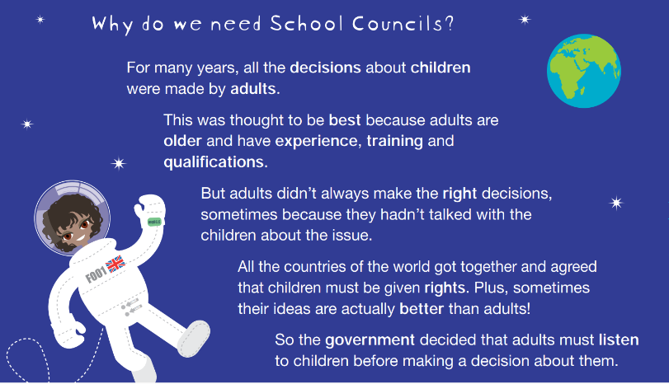

**In the session on the 20th January we discussed any new ideas (and one school council member’s idea to hand idea cards around school for pupils to fill out!). We then voted on the kindness award certificate which we hope to laminate and give out during Mrs Draper’s next kindness award assembly. We also discussed British Values and wellbeing around this ☺**

**In the session on the 27th January, as per request from the eco warriors, we designed posters advertising the eco stall selling bookmarks and promoting reading as well as environmental knowledge every Tuesday breaktime. We were so pleased with the results- as were the eco team. Well done, school council!**